Library Management System

INDEX

SR NO | DETAILS | PAGE NO
1 | Acknowledgement
2 | Introduction
3 | Development Tools
4 | Analysis [SDLC]
5 | Hardware Requirement
6 | Software Requirement
7 | Project Profile
8 | Data Flow Diagram[DFD]
9 | ER Diagram
10 | Data Dictionary
11 | Tables
12 | Screen Shots
13 | Summary
14 | Future Scope
15 | Bibliography

1

Library Management System

ACKNOWLEDGEMENT

It is a great pleasure to place on my sincere gratitude towards Mr. xyz, lecturer in College/School Name for his guidance and continuous encouragement to complete this work. I acknowledge my family and friends for their contribution and support for this report work.

Finally I would pay thanks to everyone in the Department of computer providing me an extremely overwhelming work atmosphere.

Specially thanks to our BCA Department HOD Mr. Piyush Patel and my BCA lecturer Mrs. Devanshi Dedaniya , Ms. Dhatri Dave and Mrs.

Chandani Manavar.

2

Library Management System

INTRODUCTION

Library Management System (LMS) is a software application which provides facility to make whole system automatic in place of manual. It provide facility to store data related all books and staff also maintain the current book titles, volumes and also maintain the how many members are available in library and also check the number of fines related the late submission of book and generate the information related to reserve book, missing book and search the fine using member id and generate the reports of fine paid, fines balance report, missing book report.

The Library Management System (LMS) is built on the Front End PHP 5.0 and Back End MYSQL.

This system is useful for all libraries and also useful in colleges also college library staff also can use this software and it is user friendly so user can use easily.

Currently, some library office staff maintain manually the whole library system but after this software they can maintain automatically and also saving the time and get speed.

3

Library Management System

DEVELOPMENT TOOLS

PHP 5.0 (FRONT END)

MYSQL (BACK END)

INTRODUCTION OF PHP

The Microsoft visual Basic 6.0 is the fastest way to create application for Microsoft windows whenever we are an experienced professional or brand new to basic windows programming visual basic provides us to complete set

tools to simply rapid application development.

So what is said to be Visual Basic (”VB”), part reflects to the method used to GUI (Graphical User Interface). Rather than writing numbers of line so codes to describe the appearance and to location of interface elements, we simply add objects into on screen.

The “Basic” part refers to the basic language, a language used by more programmers than any other language in history of computing. Visual Basic has evolved from objects, functions etc. we can apply GUI animation. Beginners can create useful application by learning just a few of language. Yet the power of language professional to programming language.

Whether your goal is to create a small utility fro yourself or your work group a large enterprise wide system or even distributed application spanning the globe via the tools Internet, visual Basic the tools we need.

Data Access features allow us to create database, front end application and for most popular database format, and including Ms-server and other enterprise database.

Active x technologies allow us to use the functionalities provided by other MS application.

Internet capabilities make it easy to provide access to document and applications across the Internet or intranet from within your application.

Your finished application is a true .EXE file that uses a various basic.

4

Library Management System

HARDWARE REQUIREMENT

Processor used | : | Pentium IV 1.7 MHz
Ram | : | 256 MB
Hard disk | : | 40 GB
Required space | : | 35 MB
Printer | : | Printer require for printing
Screen resolution : |  | 1024 * 768 pixels

SOFTWARE REQUIREMENT

Operating system : |  | Windows XP
Software | : | PHP 5.0 [Front End]
 |  | MYSQL[Back End]

5

Library Management System

 |  | PROJECT PROFILE
Project Title | : | Library Management System
Front-End Tool | : | PHP 6.0 (Visual Basic 6.0)
Back-End Tool | : | MYSQL
Platform Utilized | : | Microsoft Window XP Professional

6

Library Management System

DFD [Data Flow Diagram]

Symbols to be used in Data Flow Diagram

Represent a Form Link
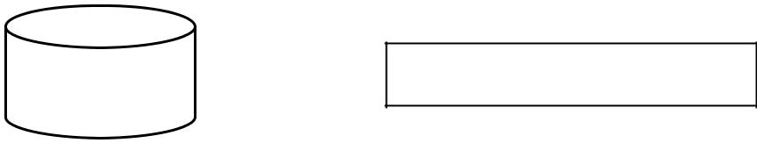

Represent a data table

Represent data flow

Represent Report

7

Library Management System

CONTEXT LEVEL DIAGRAM
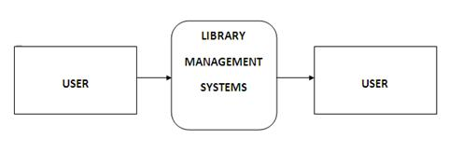

8

Library Management System

DFD LEVEL 0
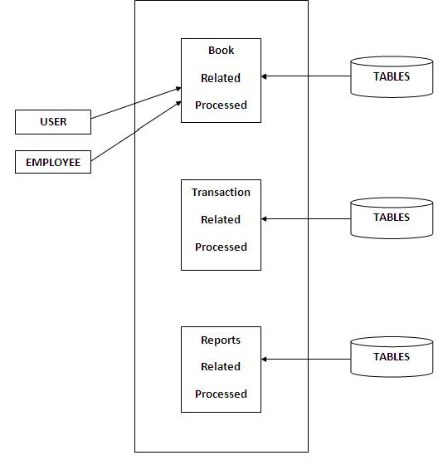

9

Library Management System

DFD LEVEL 1
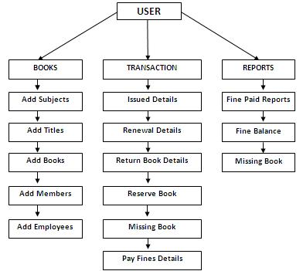

10

Library Management System

ENTITY-RELATIONSHIP DIAGRAM

One of the best known semantic modeling approaches certainly one of the most widely used is the called Entity Relationship (E-R) approach. E-R diagram constitutes a technique for representing the logical structure of a database in a pictorial manner. They provide a simple and readily understood means of communicating the salient features of the design of any given database work.

The Entity Relationship Diagram for data uses three features to describe data. These are,
- Entities, which specify distinct real-world items in an application.

- Relationships, which connect entities and represent Meaningful dependencies between them.

- Attributes, which specify properties of entities and Relationships.

Only items with the same property can be in an entity set. Once entity is identifying, the relationship are reasonably simple to identify. A thumb rule is that nouns normally describe Entities where as relationship is normally described by verbs.

An Entity may be related to more than one entity. It classify into two types, Regular Entities and Weak Entities. A Weak Entity is an entity, which is existence-dependent on some other entity.

Relationship type is known as a diamond containing the name of the relationship type in the question. The diamond border is doubled if the relationship in question is that between a weak entity type and the entity type on which its existence depends; each line is labeled “1” or “M” to indicate whether the relationship is one-to-one, many-to-one, etc.

11

Library Management System

DATA DICTIONARY
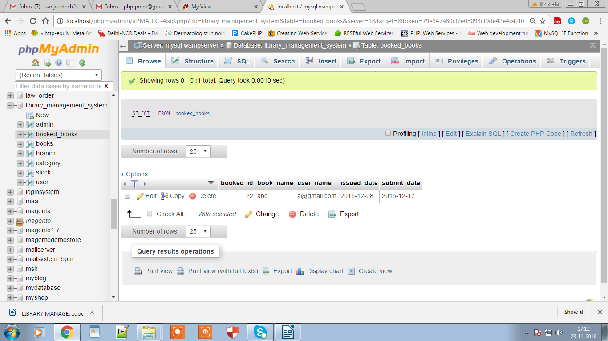
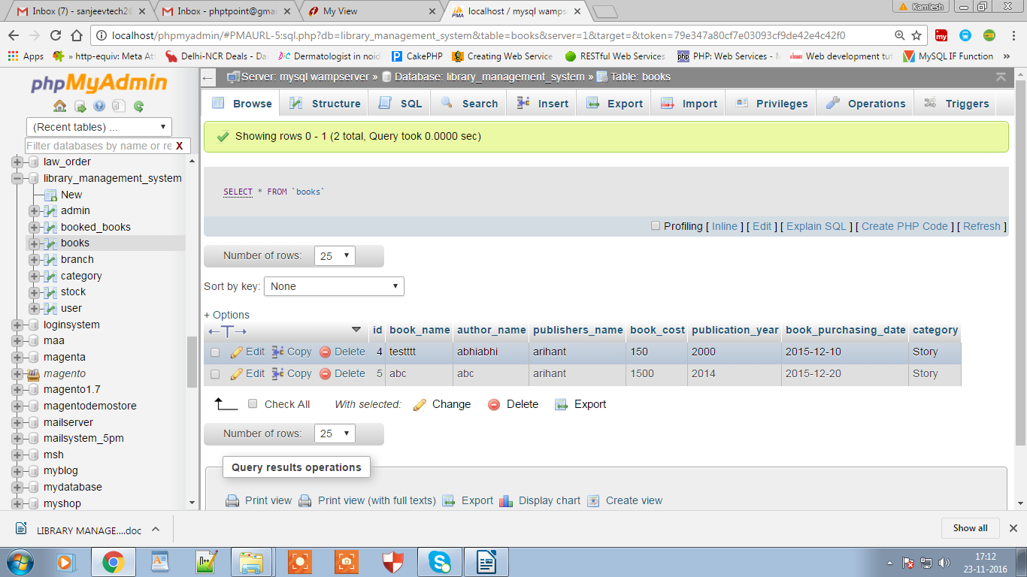
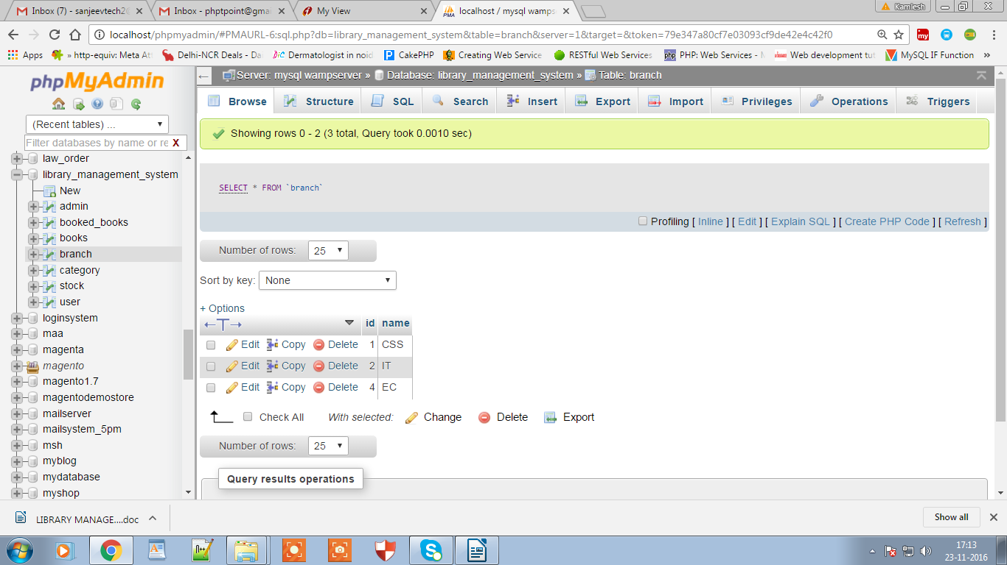
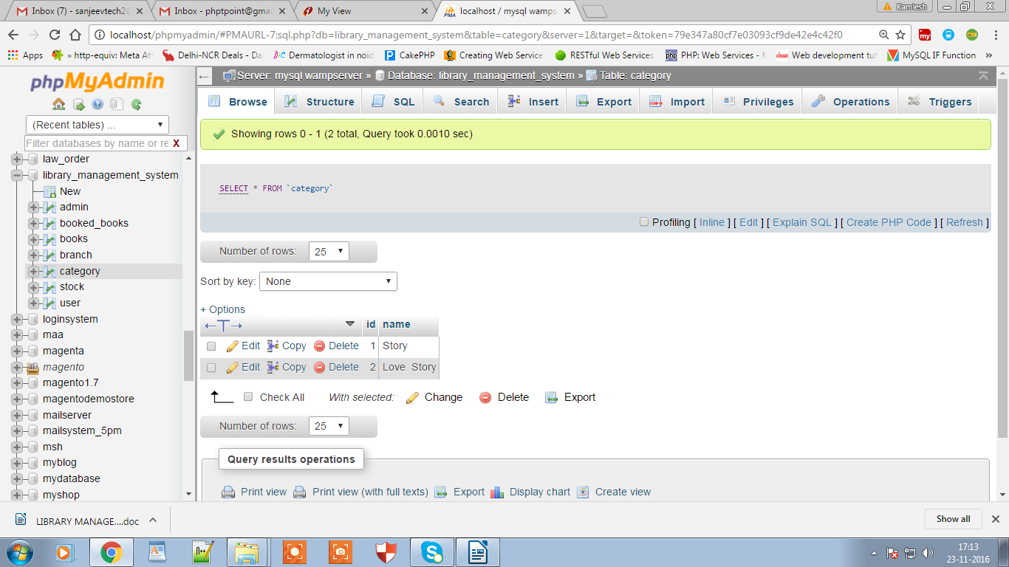
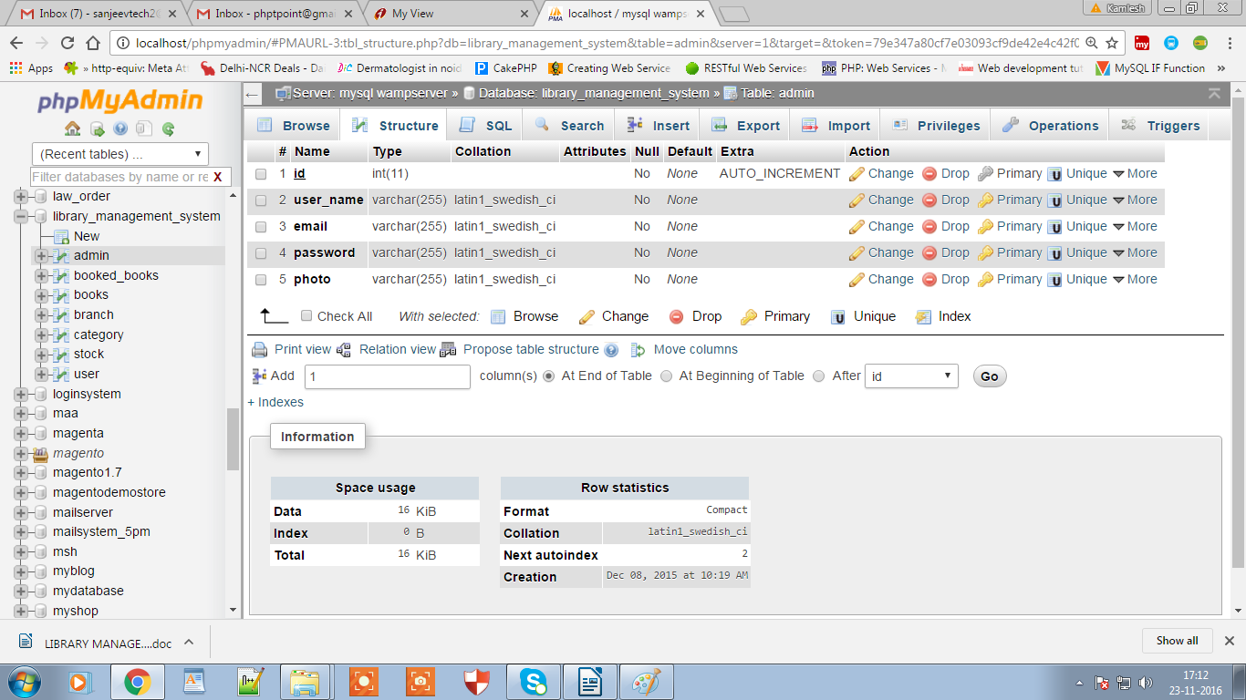

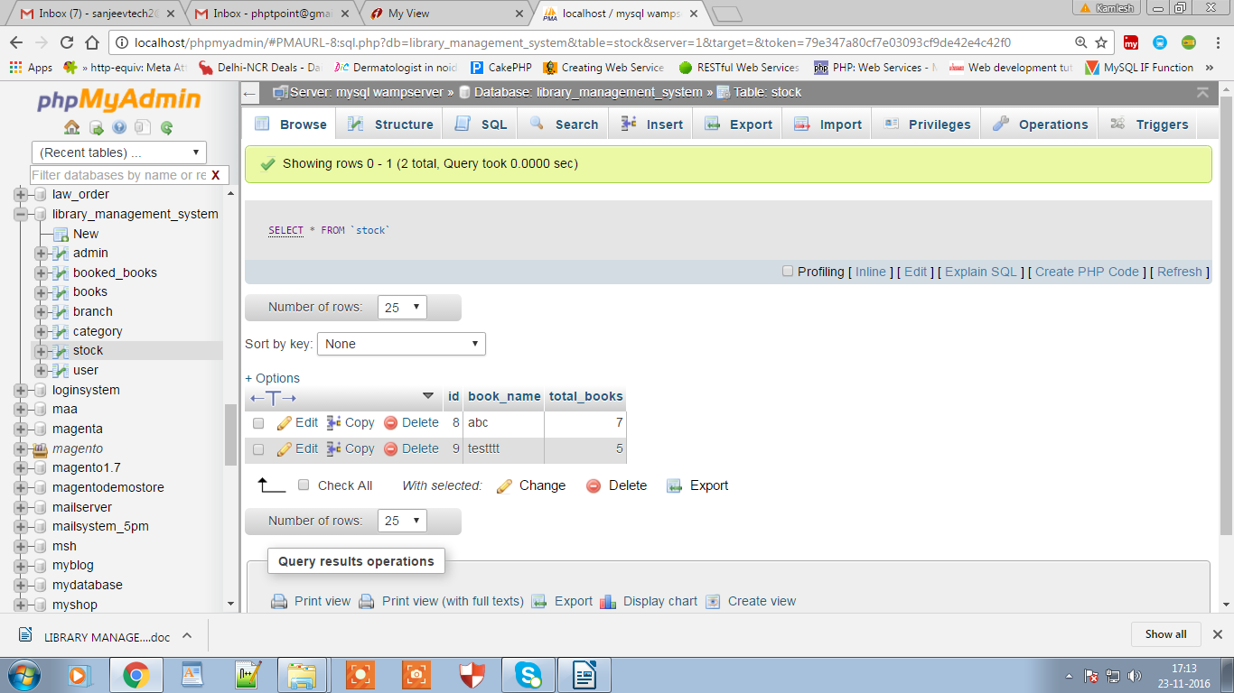

12

Library Management System
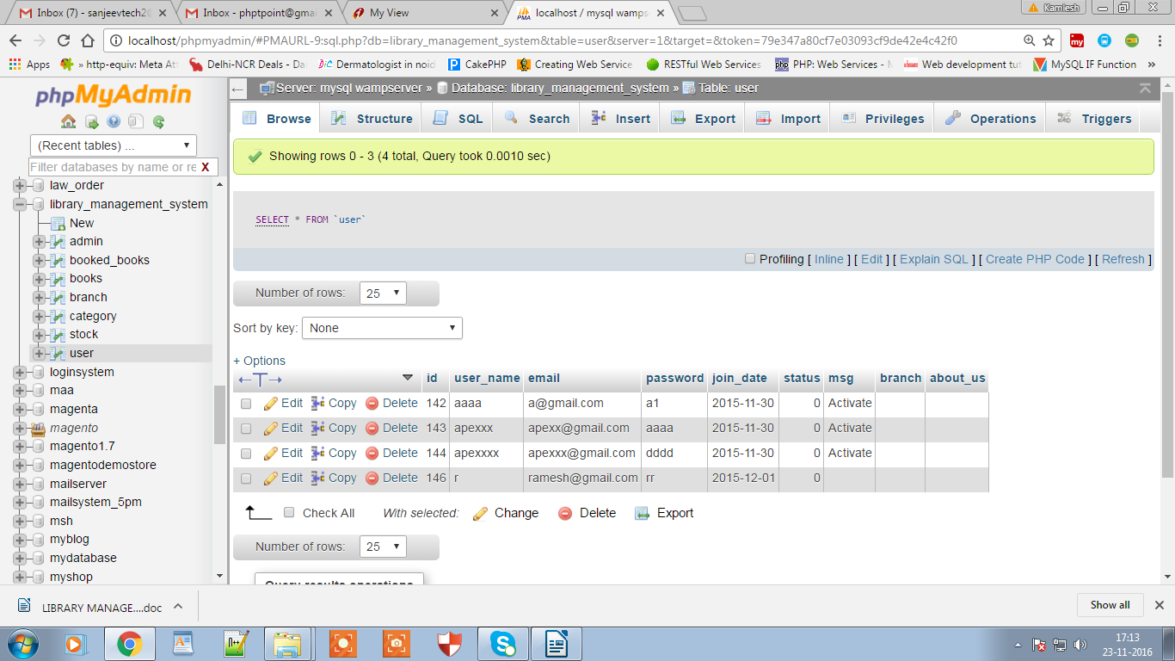

13

Library Management System

Screen Shots

Frmmain
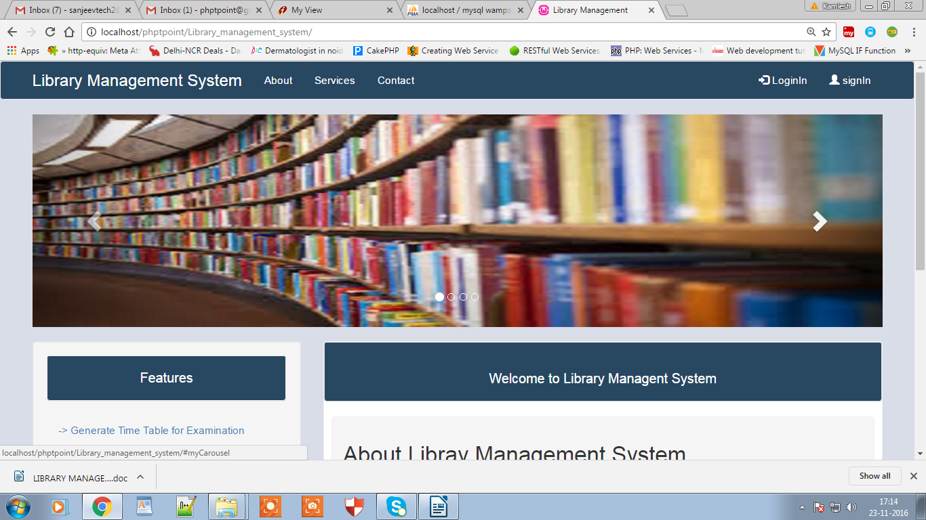

Frmissue
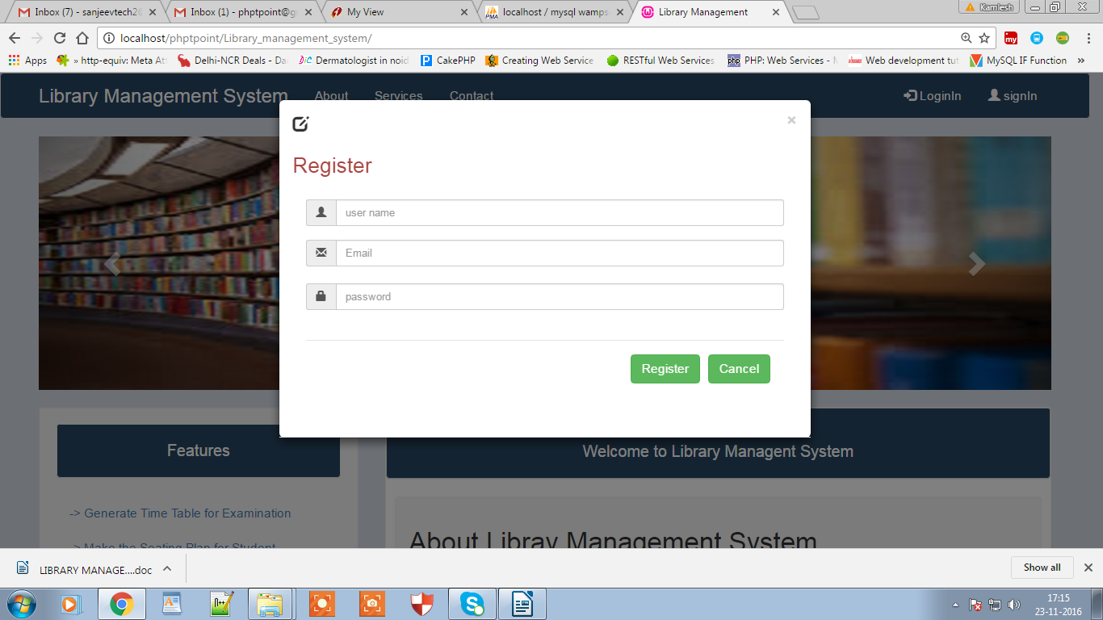

14

Library Management System

Frmissuereturn
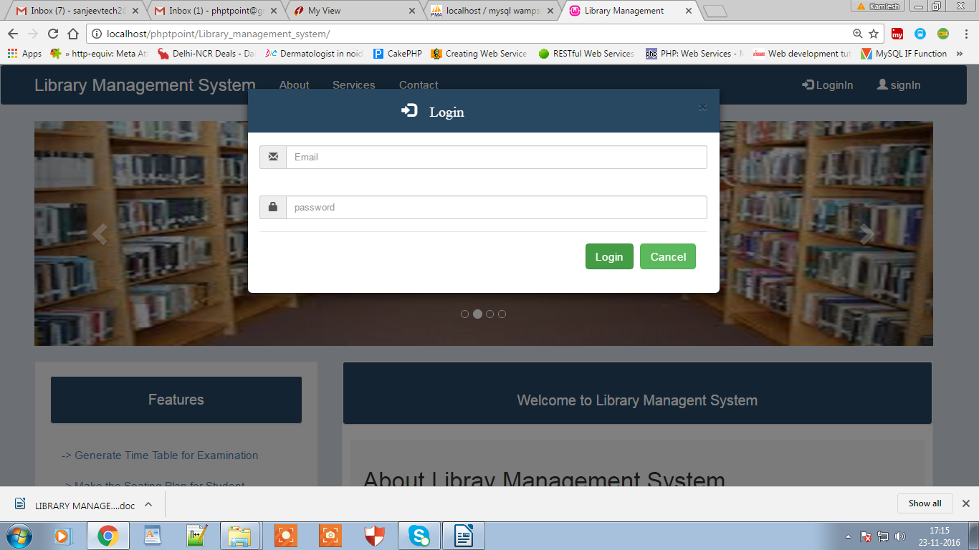

15

Library Management System

Frmnewbook
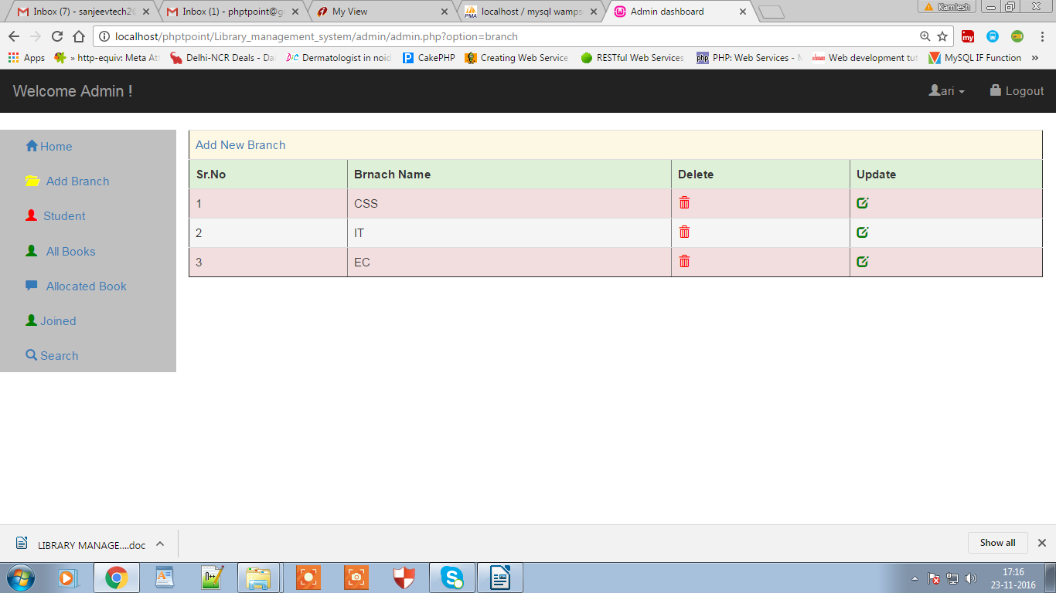

Frmnewcd
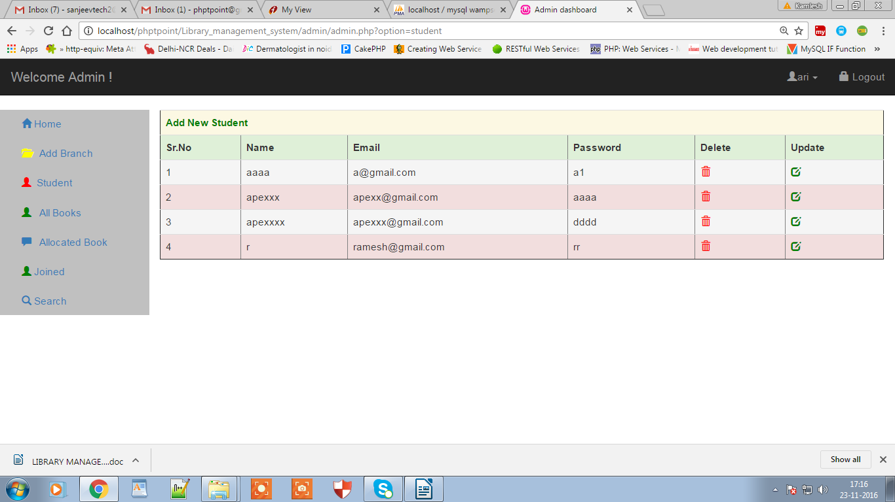

16

Library Management System

Frmnewmagazine

Frmnewpaper

18

19

20

21

22

23

Library Management System

Frmupdatemagazine

Frmupdatepaper

24

25

Library Management System

Summary

This application software has been computed successfully. It |  |  | is user
friendly, | and has | required options, which can be utilized by the | user to
perform | the desired | operations.

The software is developed using Visual Basic as front end and Access as back end in Windows environment. The goals that are achieved by the software are:

- Instant access.

- Improved productivity.

- Optimum utilization of resources.

- Efficient management of records.

- Simplification of operations

- Less processing time and getting required information.

- User friendly.

FUTURE SCOPE

We have attempted to make this project as live as possible and we think that we have put all our knowledge at work. But we have to admit that nothing is perfect in the world of software and there may be better way to do these all. In future scope we can see is that we can make it online using web tools. This software is quite better for principals for maintaining the libraries details and offering various facilities to the customers. But what we have done is under limit of our project limitation and our personal limitation.

26

